|  |  |
| --- | --- |
| **Passive Optical Components** | **Adapter** |
|  |  |

**Adapter is mainly used in the fiber connection and transformation between different patch cords and pigtails. Welltech Enterprises can offer FC, SC, LC, ST and various adapters.**

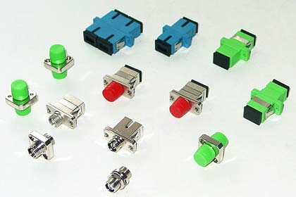

|  |  |  |  |  |  |  |  |
| --- | --- | --- | --- | --- | --- | --- | --- |
|  |  |  |  | **FEATURES** |  | **APPLICATIONS** |  |
|  |  |  |  |  |  |  |  |
|  | **●Low Insertion Loss** | | | |  | **●Optical Fiber Communication System** |  |
|  |  |  |  |
|  | **●Good Repeatability and Interchangeability** | | | |  | **●Cable TV Network** |  |
|  |  | **●FTTX** |  |
|  |  |  |  |  |  |  |
|  | **●Strong Reliability and Stability** | | | |  | **●Video Transmission** |  |
|  |  |  |  |
|  |  |  |  |  |  | **●Test Instruments** |  |
|  |  |  |  |  |  |  |  |
|  |  |  |  |  |  |  |  |
|  |  |  |  | **Parameter** |  | **Index** |  |
|  |  |  |  |  |  |  |  |
|  | **Operating temperature** | | | |  | -40℃~+80℃ |  |
|  |  |  |  |  |  |  |  |
|  |  | **Wavelength** | | |  | 850nm,1310nm,1550nm |  |
|  |  |  |  |  |  |  |  |
|  |  | **Insertion loss** | | |  | ≤0.2dB |  |
|  |  |  |  |  |  |  |  |
|  |  | **Repeatability** | | |  | ≤0.2dB |  |
|  |  |  |  |  |  |  |  |
|  | **Interchangeability** | | | |  | ≤0.2 dB |  |
|  |  |  |  |  |  |  |  |
|  |  |  | **Service life** | |  | ＞1000times |  |
|  |  |  |  |  |  |  |  |
|  |  |  |  |  |  |  |  |
|  |  |  |  |  |  |  |  |

|  |  |  |  |  |  |
| --- | --- | --- | --- | --- | --- |
| **TYPE** |  | **ADAPTER MODEL** |  |  | **ADAPTER MODEL** |
| **Adapter** |  | **FC-FC**  **SC-SC**  **LC-LC**  **ST-ST** |
| **Converter** |  | **FC-SC** |
|  |  | **SC-LC** |
|  |  | **FC-ST**  **ST-SC** |
|  |  |  |